What Aycan has done:

Due to the plan, this week we are supposed to develop the logical basis of the for a ball detection algorithm. As stated in the previous weekly report, we already developed a color detection algorithm, which omits the undesired colors from the original image and creates a reduced version of it. Starting from this code, in this week we took a step further on the development of the image processing algorithm and successfully implemented a ball detection algorithm.

Due to the practical reasons the test demo, which is provided below, is implemented on the MATLAB. In the first step we worked on two sample images shown in Figure 1. As observed in these images there are two balls in the provided images, which colored red and green respectively. The main aim of the developed algorithm is deciding is there any green ball. If no green ball present, red screen is shown. If ball is present the original image is shown. The results of the given images are provided in Figure 2. Moreover, when the ball is present it also finds the approximate center of this ball. The closeup for marker is shown in Figure 3.

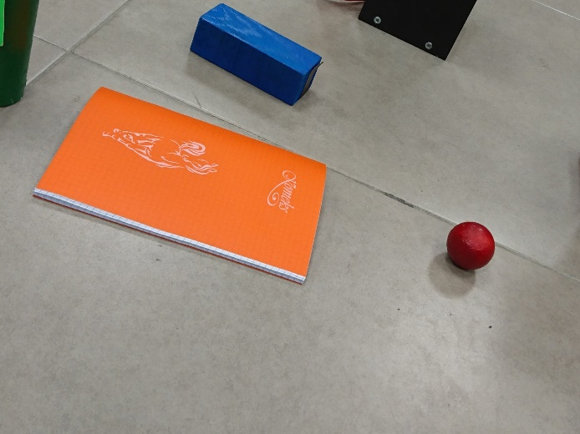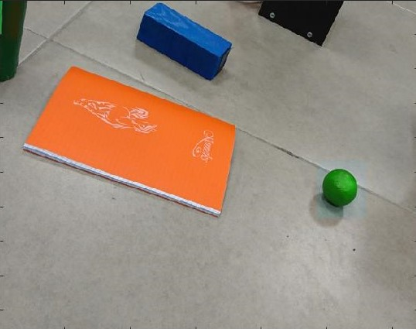

Figure 1: Sample images with red(left) and green(right) ball

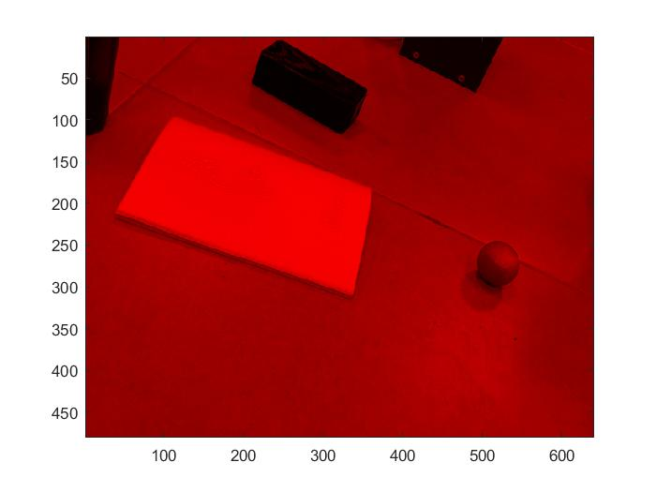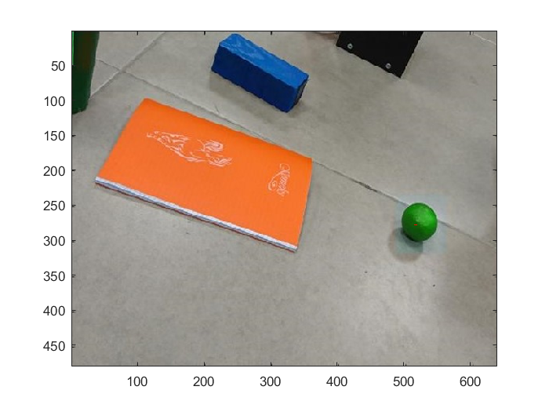

Figure 2: The resultant image of algorithm with sample images with red(left) and green(right) ball

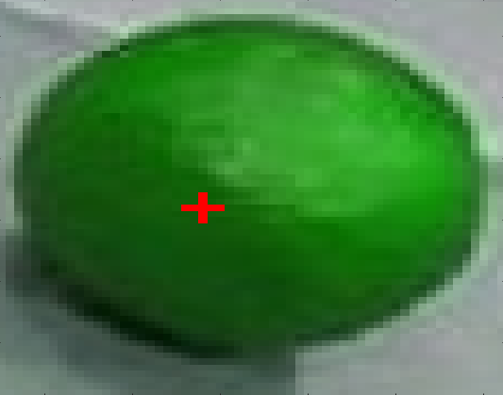

Figure 3: The closeup image of marker indicating the approximate center of ball